# [LAW & ORDER: SPECIAL VICTIMS UNIT Promotes Demore Barnes](https://www.givememyremote.com/remote/2020/10/06/law-order-special-victims-unit-promotes-demore-barnes-season-22/)

October 6, 2020 by [Marisa Roffman](https://www.givememyremote.com/remote/author/marisa/)

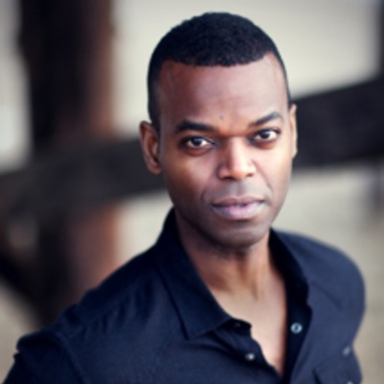

***Credit: Andre Niesing***

Deputy Chief Garland is sticking around on LAW & ORDER: SPECIAL VICTIMS UNIT: Demore Barnes has been bumped up to series regular for the upcoming season 22 of the NBC drama, [Give Me My Remote](https://www.givememyremote.com/remote/) has learned.

[Barnes joined the long-running procedural in 2019](https://www.givememyremote.com/remote/2019/10/04/demore-barnes-svu-deputy-chief-garland/), in a recurring capacity, in the wake of [Peter Gallagher’s exit as Chief Dodds,](https://www.givememyremote.com/remote/2019/12/20/law-order-special-victims-unit-peter-gallagher-dodds-return/) as Captain Benson’s (Mariska Hargitay) new boss. Though he only appeared in six episodes of the COVID-shortened season, one of the final installments of the year—”Garland’s Baptism by Fire”—dove deeper into his adjustment into the unit and his own backstory.

The full-time addition of Chief Garland is the second in as many years for the NBC procedural, after Jamie Gray Hyder, who plays Officer Kat Azar Tamin, [was made a series regular in season 21](https://www.givememyremote.com/remote/2019/11/01/law-order-special-victims-unit-jamie-gray-hyder-series-regular-season-21/).

In addition to SVU, Barnes also has his final year of AMERICAN GODS ahead. He previously did arcs on TITANS, 12 MONKEYS, THE FLASH, THE UNIT, and SUPERNATURAL.

<https://twitter.com/DemoreBarnes/status/1310611852251090944?s=20>